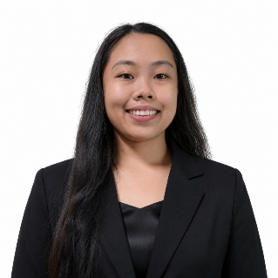
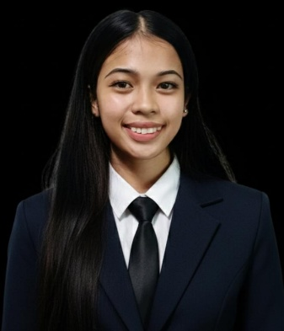
MARIE JOY W. DE GUZMAN
Purok 7, Union, Cauayan City, Isabela
📞 09127118331
✉️ mariejoydeguzman15@gmail.com

CAREER OBJECTIVE
To find a job where I can use my communication and customer service skills while gaining more experience and learning new things. I am willing to take on new responsibilities, work well with others, and do my best to contribute to the company through hard work, dedication, and a positive attitude.
EDUCATIONAL BACKGROUND
Tertiary
Isabela State University-Cauayan Campus
Bachelor of Science in Information Technology
4th Year
Secondary
Cauayan City Science and Technology High School
(2022-2023)
Primary
Union Elementary School
(2016-2017)
SKILLS
- Excellent verbal communication and interpersonal skills
- Strong customer service and customer relations
- Basic sales and product promotion skills
- Ability to work under pressure and meet deadlines
- Fast learner with a willingness to learn new tasks
- Flexible and adaptable to different work environments
- Good time management and organizational skills
- Responsible, reliable, and detail-oriented
- Ability to work independently and as part of a team
WORK EXPERIENCE
Promo Diser(Part-Time)
Push Selling – Cabaruan Cauayan City Isabela
DE GUZMAN, MARIE JOY W.
Applicant

